SIMPLE PORTFOLIO
@CREATIVITY THINK (9483175986/7019689991)

ABSTRACT:
Simple Portfolio is a static web-based application designed to showcase an individual’s personal profile, skills, projects, and contact information in a clean and professional manner. The platform provides visitors with an easy-to-navigate interface to view the creator’s achievements and reach out via social links. Developed using HTML and Bootstrap, the system ensures a responsive, visually appealing, and lightweight user experience suitable for freelancers, students, or professionals seeking a digital portfolio presence..

INTRODUCTION OF THE PROJECT:
In the digital era, a personal portfolio website is essential for showcasing skills, projects, and professional achievements. Traditional resumes or offline portfolios are limited in reach and interactivity. Simple Portfolio addresses these limitations by providing a web-based static site that presents information in an organized and visually appealing manner. Visitors can quickly access relevant information, while creators can easily maintain and update content by editing the static files..

PROJECT OBJECTIVES:

• Display personal information including profile and biography
• Showcase skills, projects, and achievements in a structured layout
• Provide links for contact and social networking
• Ensure responsive design across multiple devices using Bootstrap
• Maintain a lightweight and fast-loading static website
• Allow easy content updates by directly editing HTML/CSS files
• Provide a professional and visually appealing digital presence
• Support freelancers, students, and professionals in self-promotion

PROBLEM OF THE STATEMENT:
Individuals often struggle to create a professional digital presence for personal branding or freelance work. Traditional resumes lack interactivity and online visibility. Simple Portfolio solves this problem by offering a static, well-structured website where visitors can easily access professional information, contact details, and project showcases, thereby improving online visibility and credibility..

MOTIVATION OF THE PROJECT:
• To create a professional digital portfolio for personal branding
• To provide an accessible platform to showcase skills and projects
• To offer a lightweight and fast-loading website
• To reduce dependency on complex CMS or backend systems
• To allow easy updates and customization via static files
• To improve visibility for freelancers, students, and professionals
• To enhance engagement through social and contact links

BLOCK DAIGRAM OF PROJECT:

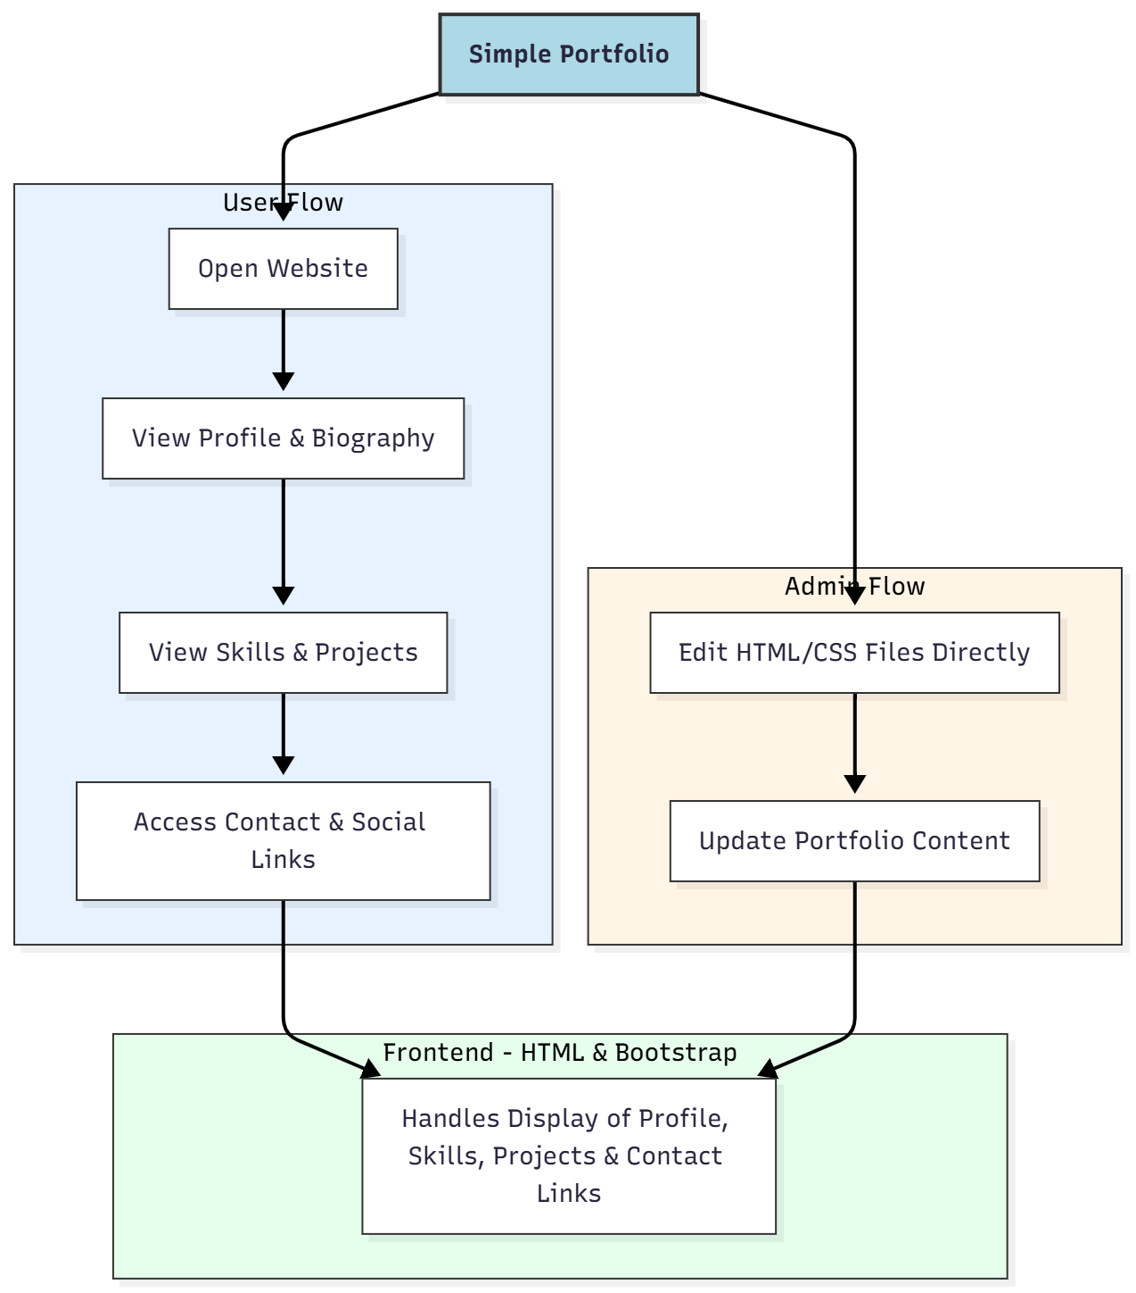

WORKING OF THE PROJECT:
Visitors access the website using any modern browser. They can browse the profile section, review the individual’s skills, explore project showcases, and use contact/social links to reach out. Since the site is static, all updates to content, design, or sections are made by editing the HTML and CSS files directly. Bootstrap ensures a responsive layout that adapts seamlessly across desktops, tablets, and mobile devices, providing a professional and consistent user experience..

SOFTWARE REQUIREMENT:
- Backend:
  - Python 3.x
  - Django
  - Django REST Framework
  - SQLite/PostgreSQL
- Frontend:
  - Node.js and npm
  - React.js
  - Axios
- Development Tools:
  - Visual Studio Code
  - Postman (for testing APIs)
  - Git/GitHub (for version control)
- Server/Deployment (Optional):
  - Gunicorn, Nginx, or Heroku/AWS for hosting

ADVANTAGES OF THE PROJECT:

• Professional and visually appealing portfolio
• Fast-loading static website
• Easy to browse skills, projects, and contact information
• Fully responsive with Bootstrap
• Low-cost and simple maintenance
• No backend or database dependency
• Easy to update content via HTML/CSS
• Suitable for freelancers, students, and professionals

APPLICATIONS OF THE PROJECT:
• Personal CV-style portfolio
• Freelancer showcase websites
• Intro or landing pages for students/professionals
• Small personal branding websites
• Portfolio display for projects or achievements

REFERENCES:

- Django REST Framework Documentation — Django Software Foundation. Django Documentation. Available: https://docs.djangoproject.com/
- Django REST Framework. DRF Documentation. Available: https://www.django-rest-framework.org/
- React. React Official Documentation. Available: https://reactjs.org/docs/getting-started.html
- Redux. Redux Documentation. Available: https://redux.js.org/introduction/getting-started
- PostgreSQL Global Development Group. PostgreSQL Documentation. Available: https://www.postgresql.org/docs/
- MySQL. MySQL Reference Manual. Available: https://dev.mysql.com/doc/
- Git. Git Documentation. Available: https://git-scm.com/doc
- Node.js. Node.js Documentation. Available: https://nodejs.org/en/docs/
- Axios. Axios Documentation. Available: https://axios-http.com/docs/intro
- Socket.io Documentation – https://socket.io/docs/

